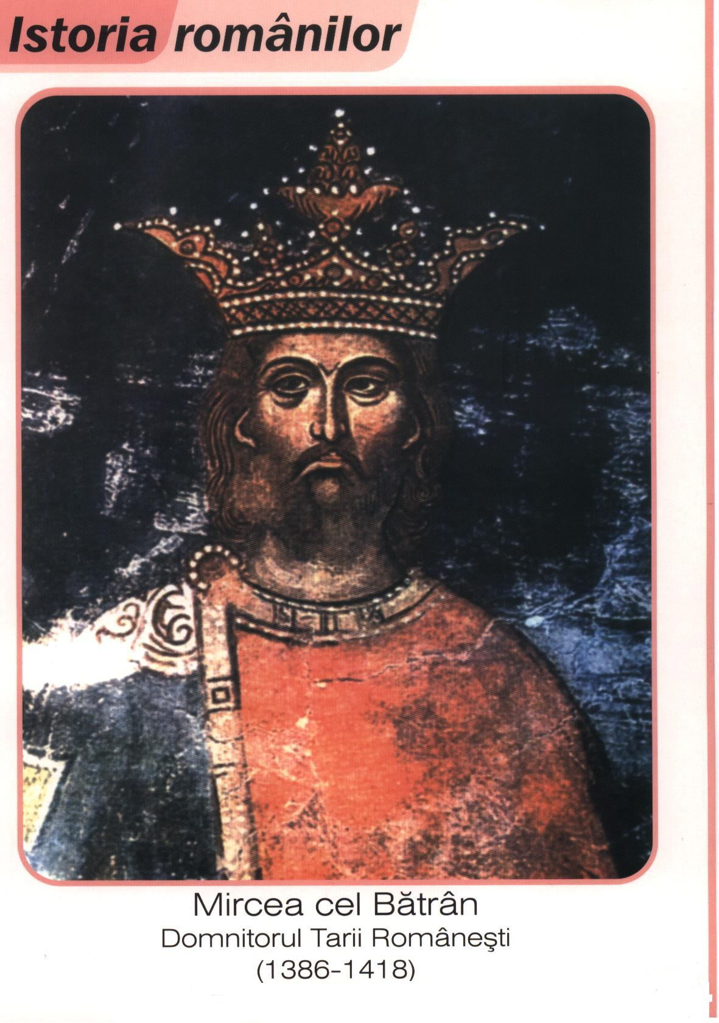
Numele Domnitorului : _____________________________________

Ţara unde a domnit ________________________________________

Anii de domnie :__________________________________________

Localităţi unde a avut loc bătălii : ____________________________

_______________________________________________________
________________________________________________ ______
__________________________________________________________________________________________________________________________________________________________________________________________________________________________

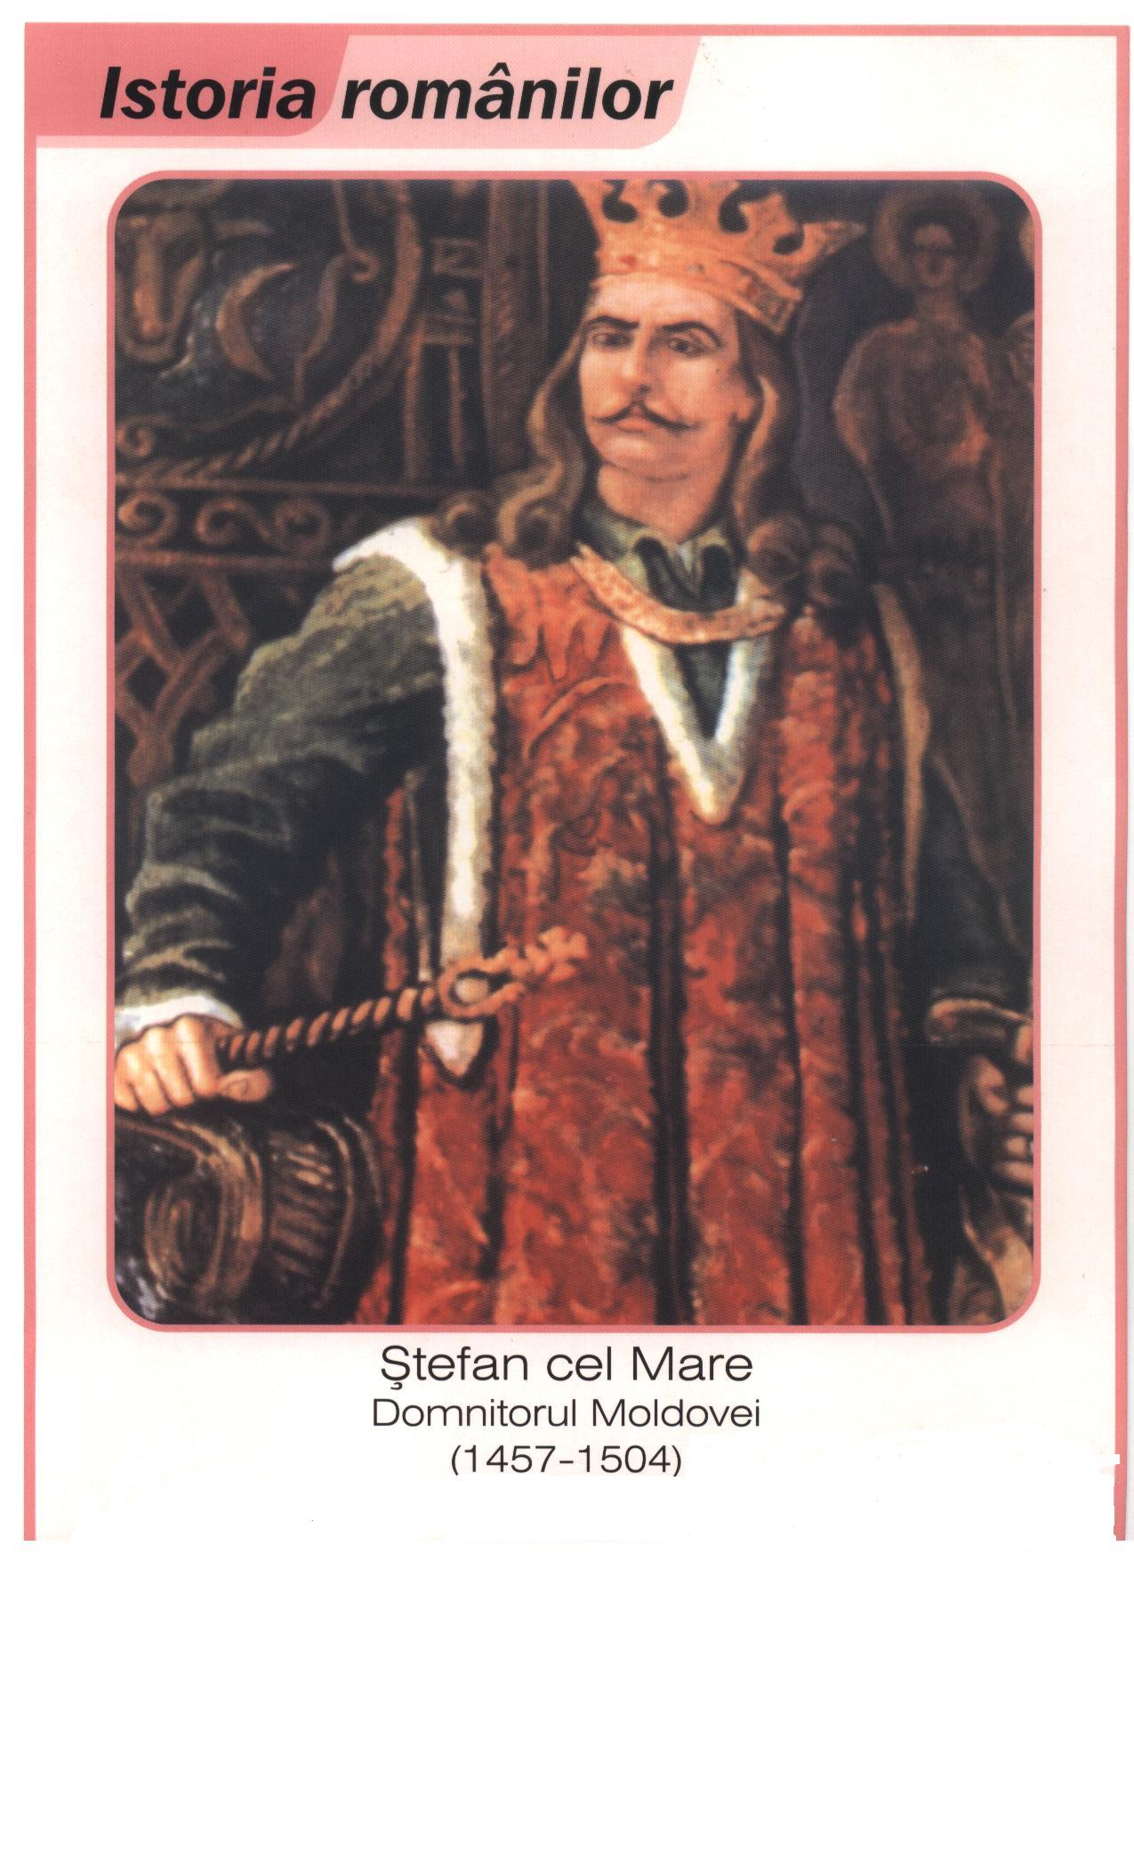
Numele domnitorului :___________________________________________

Ţara unde a domnit : ____________________________________________

Anii de domnie : _______________________________________________

Localităţi unde au avut loc bătălii : ________________________________
____________________________________________________________
Pentru ce a fost reţinut în istorie:___________________________________
______________________________________________________________________________________________________________________________________________________________________________________________________________________________

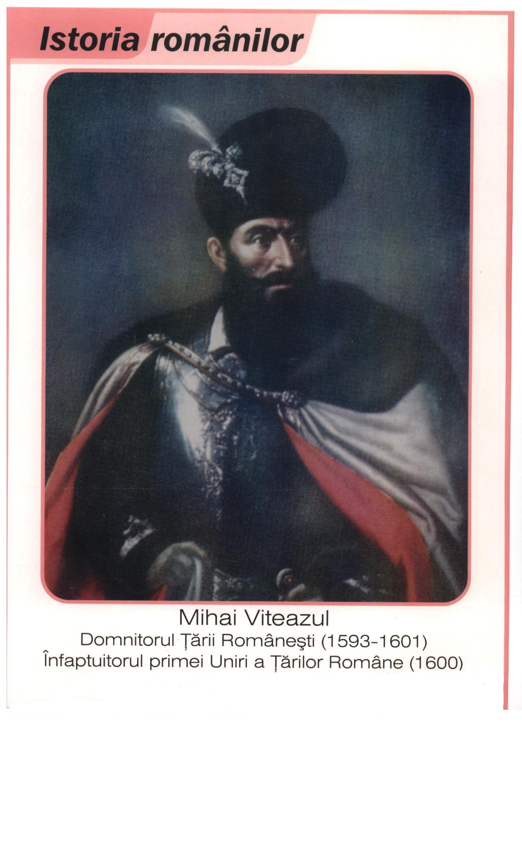
Numele domnitorului : _________________________________________

Ţara unde a domnit : ___________________________________________

Anii de domnie : ______________________________________

Localităţi unde au avut loc bătălii . _____________________________

Pentru ce a fost reţinut în istorie: ________________________________
___________________________________________________________
___________________________________________________________________________________________________________________________________________________________________________________________________________________________________________

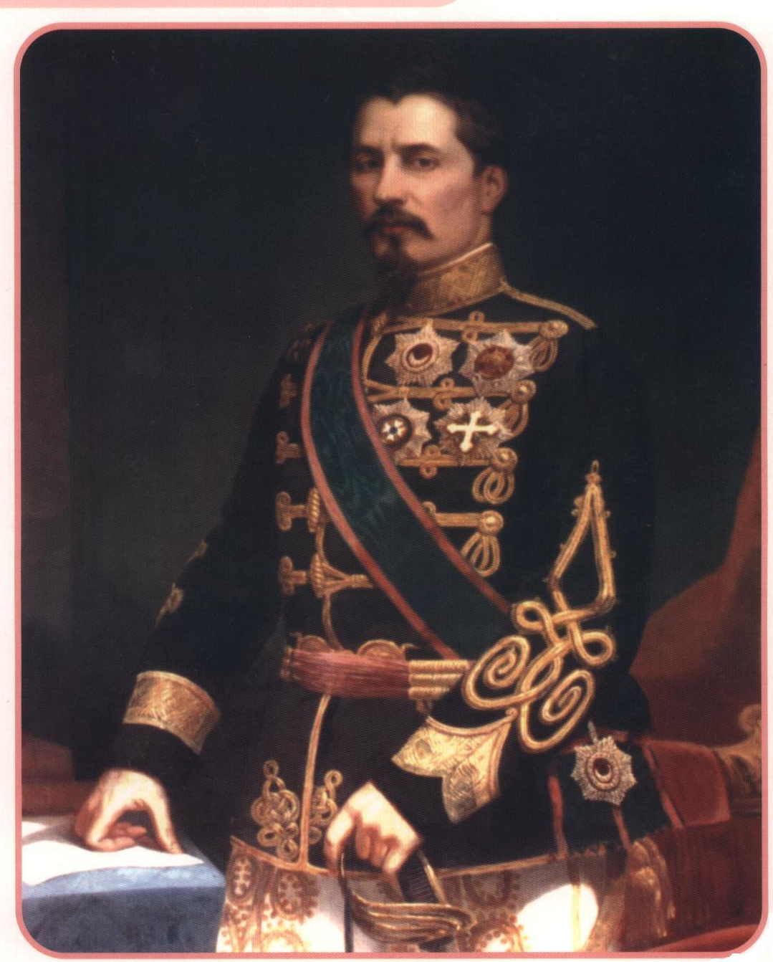

________________________________
(numele domnitorului, anii de domnie)

Cine a fost ?
_________________________________________________________________________________________________________________________________________________________________________________________________________

Faptele sale
__________________________________________________________________________________________________________________________________________________________________________________________________________________________________________________________________________________________________________________________________________________________________________________________________________________________________________________________________________________________________________________________________________________________________________________________________________________________________________________________________________________________________________________________________________________________________________________________________________________________________________________________________________________________________________________________________________________________________________

Amintirea lui Al I Cuza se păstrează şi azi în povestiri precum:
____________________________________________________________________________________________________________________________________________________________________________________________________________________________________________________________________________

