CONSOLIDATION WORKSHEET, 3RD GRADE

- Write the nouns in the correct group: GIRL, CHILD, ORANGE, MOUSE, BOY, WOMAN, FOX, BRUSH, CAT, SHEEP, FROG, BANANA, BABY, FOOT, BOOK, BALL, MAN, TRAIN, TOOTH, CHERRY.

Singular Plural Singular Plural
BOX - BOXES APPLE - APPLES



Singular Plural
FISH - FISH

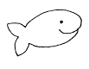

II. 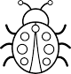  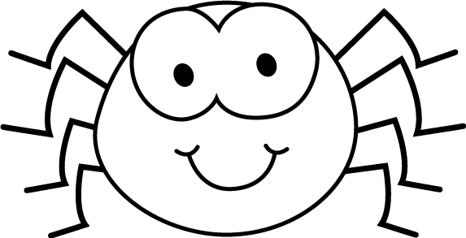 Bugs, 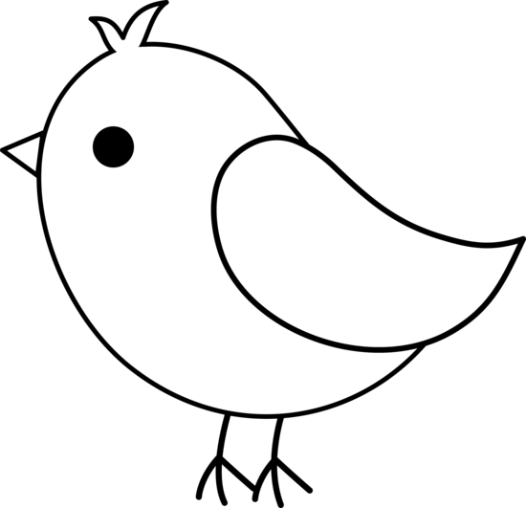 birds, animals and……..MATHS?!?! Yes! Let’ find out! Complete the missing information.

- one spider has got eight legs – two ……………… …………. got ………………………. legs

- one elephant has got four legs – five 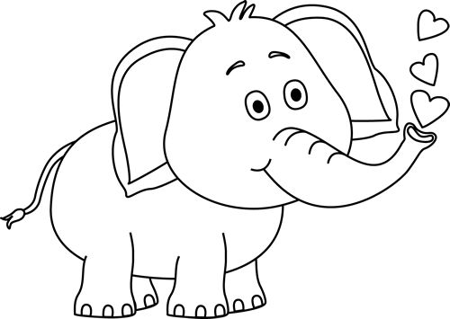 ……………….. ……… got ………………………… legs
  - Read and underline:

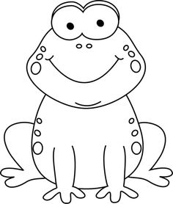 Frogs are green. They have/has got a 1 ) fat/thin body, 2) small/big eyes and 3) long/short legs. They 4) can/can’t crawl but they 5)can/can’t jump. Frogs are very funny! ☺

  - Read and answer:
e.g. Have you got a pet? Yes, I have

1. Have you got brown eyes? ………………………………………………………………………………

2. Can you fly? ……………………………………………………………………………….

3. Have you got a parrot? ……………………………………………………………………………….

4. How old are you? ………………………………………………………………………………..

5. Can you draw? …………………………………………………………………………………

!!!Va rog sa ma contactati daca aveti neclaritati la adresa de e-mail ralucatatar90@yahoo.com

.

