WORKSHEET 1stGRADE

I. Look and underline the correct word:

1.  PEAR/APPLE

2. 3. 4.
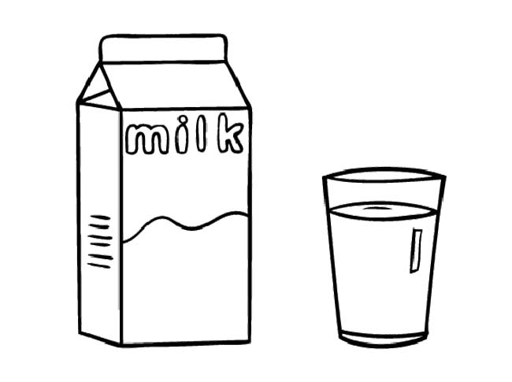TEA/MILK 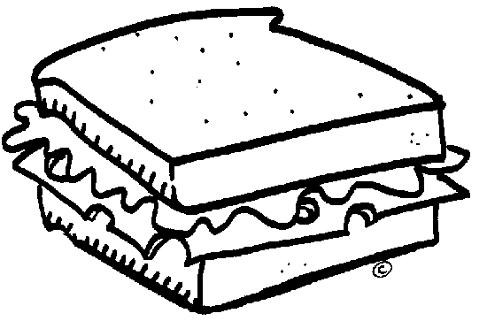SANDWICH/PIZZA 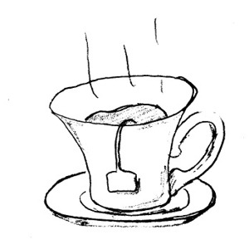 TEA/COFFEE

5. 6. 7.
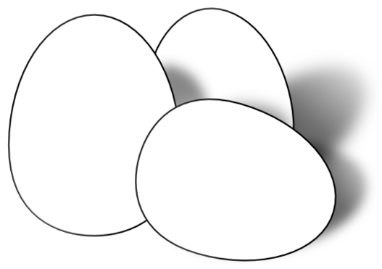 APPLE/EGGS  BISCUIT/CHEESE  CHEESE/ ICE CREAM

II. Draw your menu for a special day! (Deseneaza meniul tau pentru o zi speciala!)

