WORKSHEET, 2ND GRADE

- Colour the animals and underline the correct word:

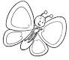 a) bird/butterfly 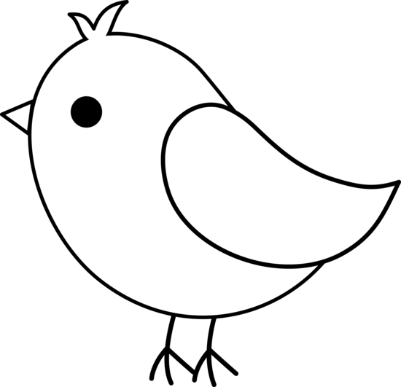 d) ladybug/bird

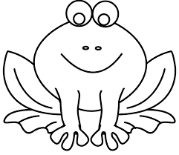 b) elephant/frog 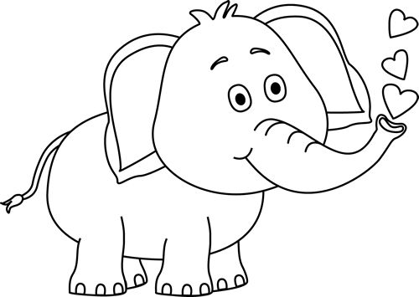e) elephant/ frog
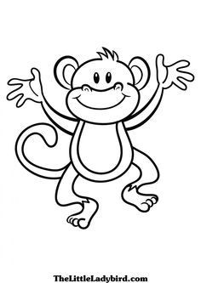 c) monkey/dog 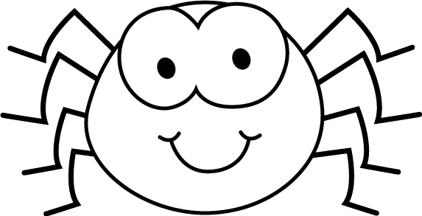 f) bird/spider

- Circle the correct word:

- An can fly/walk.
- A 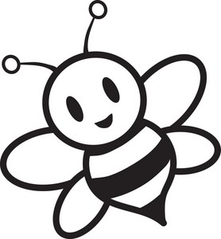 can swim/fly.
- A 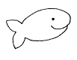can run/swim.
- A 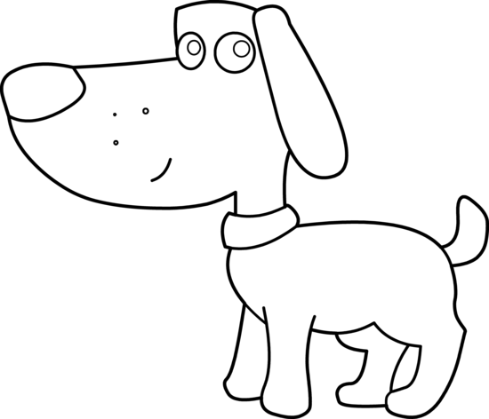 can fly/run.
- A 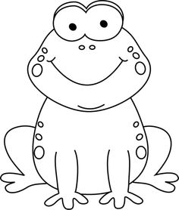 can walk/jump.
- A can hop/walk.

- Complete with A or AN:

……… BIKE …………. ELEPHANT
……… GIRL …………. UMBRELLA
……… OWL …………. LION
……… PARROT …………. TOMATO
……… ORANGE …………. ANGEL

- Match the columns:

13 TWENTY
17 NINETEEN
19 THIRTEEN
14 SEVENTEEN
20 FOURTEEN
15 SIXTEEN
11 TWELVE
18 FIFTEEN
12 ELEVEN
16 EIGHTEEN

